Faster Fractal Image Compression Using Quadtree Recomposition
David J. Jackson, Wagdy Mahmoud, William A. Stapleton, Patrick T. Gaughan
Image and Vision Computing, Vol. 15, No. 10, pp. 759-767, Feb. 1997
Abstract
In this paper we present a new quadtree recomposition (QR) approach. In this approach, quadtree subblocks of an image are iteratively recombined into larger blocks for fractal coding.
- Introduction
An analysis of the QD approach indicates that many calculations performed are not required. Therefore, a new QR approach is introduced which reduces compression time by eliminating many unnecessary calculations.
- The Fractal Transform

- Quadtree Partitioning
A quadtree decomposition partitions the image into large range blocks initially. The transformation is acceptable if the distance between the blocks is lower than an acceptable threshold. If it is discarded, the range block is divided into four subblocks.
- Aspects of the QD Algorithm
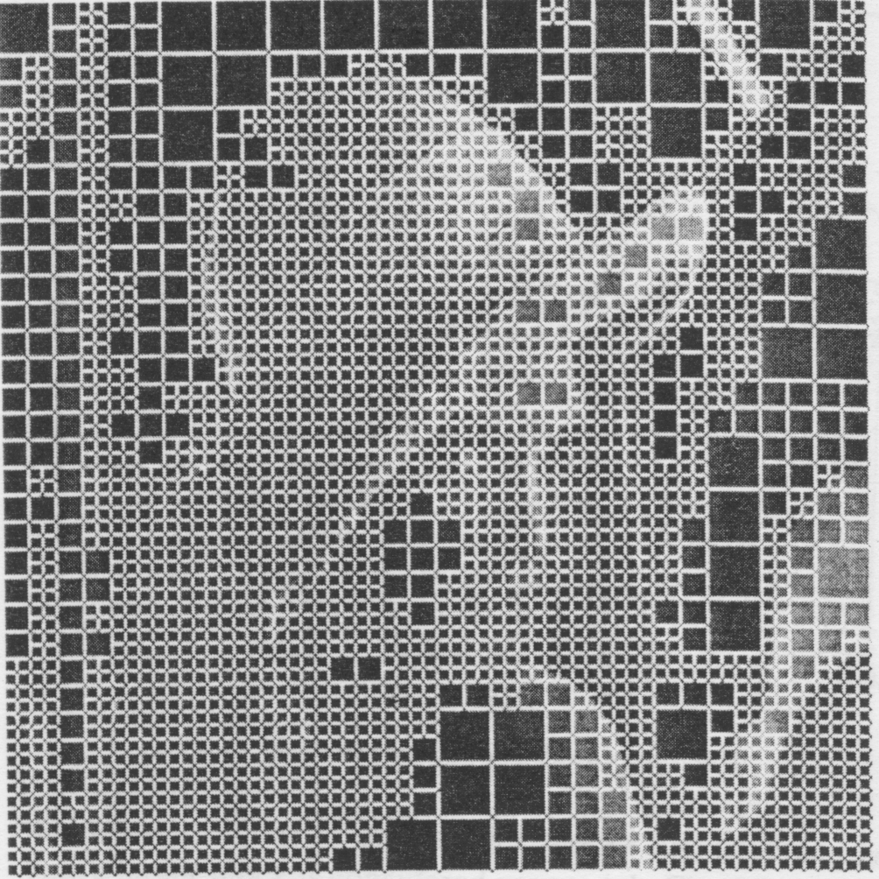
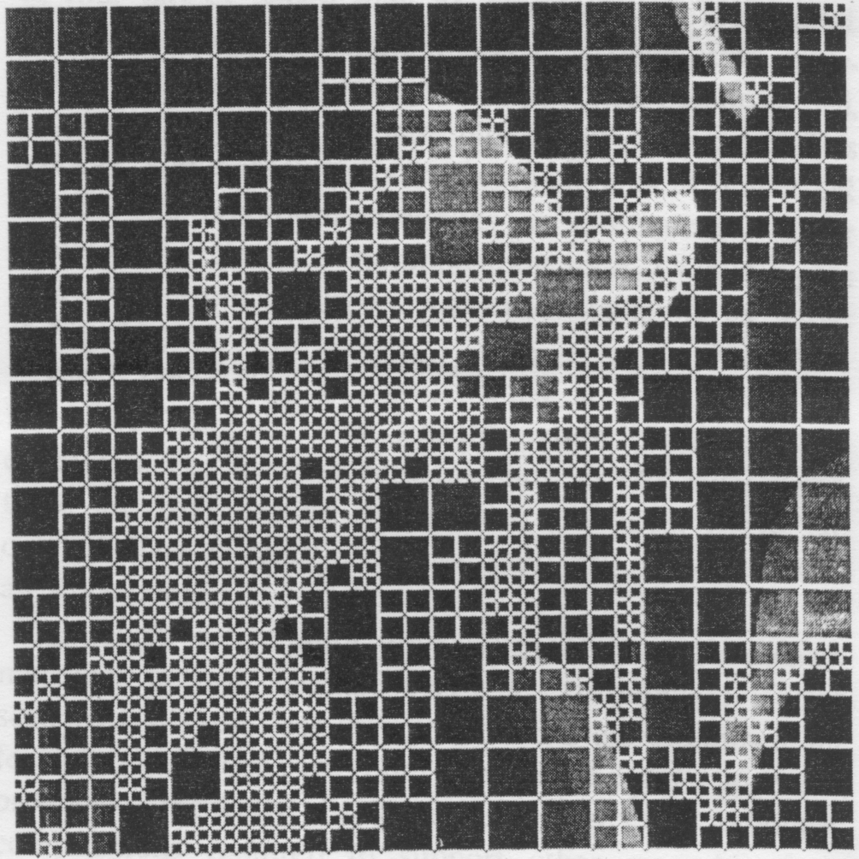

- The QR Algorithm
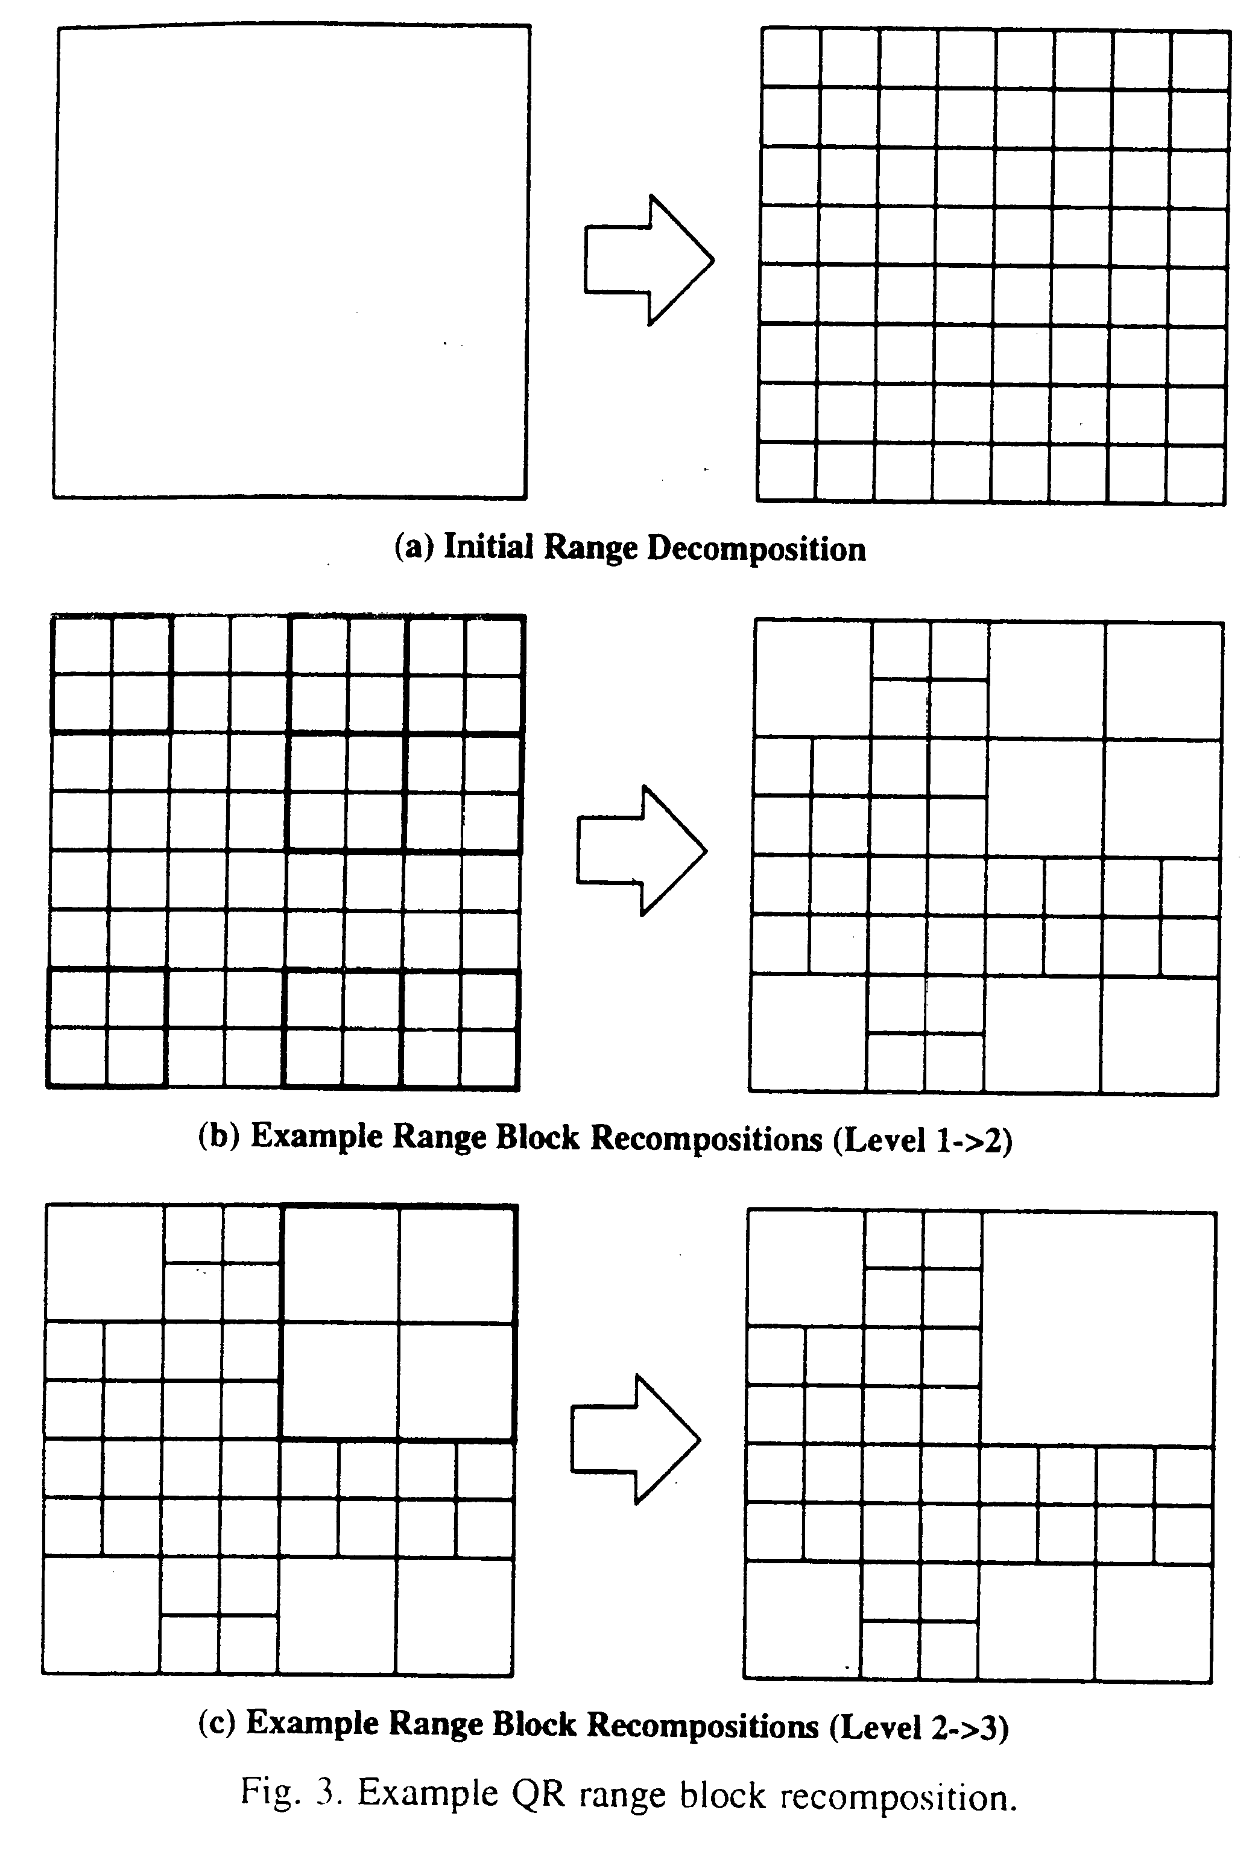
- QD versus QR analysis

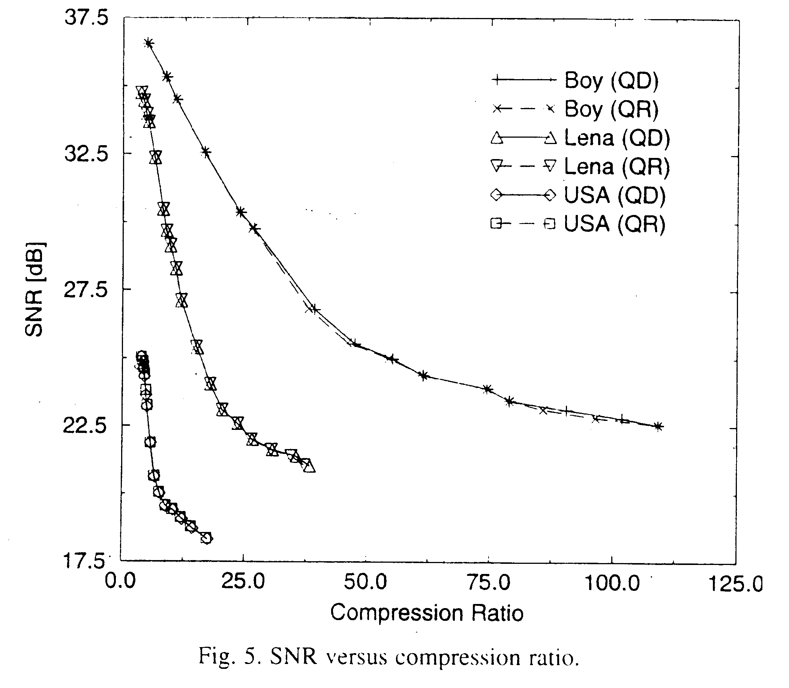

- Conclusion
The QR algorithm proves highly efficient and is shown to provide consistently superior compression time performance when compared to the QD algorithm.

Created by : Chia-Hao Yang
Date : July 17, 1998

